Tableau top tip
Resetting saved filters

Saving filters within Tableau allows you to set what options Tableau loads within a particular report, ensuring the content is relevant to you and saving you having to re-apply the filters every time you load the report. When the data within the source system changes, for instance Finance hierarchies are update this can cause a previously saved filter to fail and Tableau will load a blank report with no data present. When this happens you will need to re-apply and re-save your filters.

How to identify when a saved filter has failed
If a saved filter ‘fails’ Tableau will load a blank report. The way to identify if this is due to a failed saved filter is to look in the filters at the top of the report and identify any filter that has a () round it. In the example below ‘Select a Team name’ is the filter that has failed. This signifies Tableau has not been able to find the saved filter option within the current data set, i.e. it no longer exists as an option.

How to update your saved filters

Step 1: Remove all existing filters
For each of the filters in your report (in the above example all 4 filters) you will first need to remove any existing saved options. To do this hover over the top right of the filter and a red cross will appear. Click this to remove the filter and then repeat for all other filters in the report.

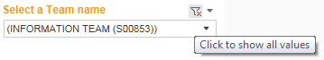
Step 2: Re-apply your filters
For each filter now re-apply the options you require
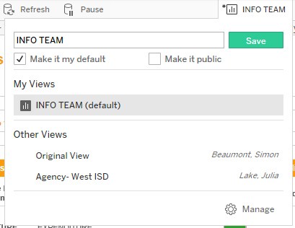
Step 3: Save your filters
Click on the filter save filter button at the top of the report and re-save your filter. Tableau will now load the correct data every time you access the report and for any subscriptions you have live for that reports.

