Tableau top tip
Subscriptions

We realise that not everyone will have the time to access Tableau as frequently as they may like to; in these circumstances Tableau allows you to subscribe to a report so you receive a copy of the report in your inbox on a frequency of your choosing.

When subscribing to a report Tableau will email your Southern Health email address with a copy of the report on a daily, weekly or monthly basis (depending on your selected preference). The report will be a static version of the report and will be available to you within your email without the need to connect to Tableau. This may be useful to you when wanting to keep historical snapshots of performance to enable you to compare current performance with performance from a number of weeks ago.

Important consideration when sharing subscribed reports with other individuals
Please remember that within a number of Tableau reports there may be some element of patient identifiable data (RiO ID, Patient Name, Date of Birth, Age of NHS Number). Tableau is able to email this information to you on your Southern Health email address as it has been shared with you securely through internal systems however should you wish to forward a Tableau subscribed report to other individuals you are required to follow Trust guidance and only send this from your NHS net account to other NHS net accounts. Do not forward on the email directly from your Southern Health email address.
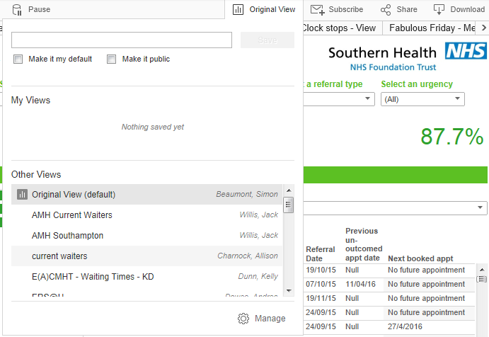

Step 1: Selecting the report
Open the report you wish to subscribe to
You can subscribe to any Tableau report that you have access to.

Apply any saved filters to the report that you need applied to the subscription (Quick guide available)
Click on Original View and apply a saved filter or create a new saved filter to ensure your subscription only sends you the data you require to see.

Step 2: Click on subscriptions
Click on the mail icon in the top right corner of the report

Step 3: Selecting your schedule
Click on the schedule drop down and select the frequency for which you wish to receive the report

It is also possible to change the title of the email you are sent by editing the “Subject” box

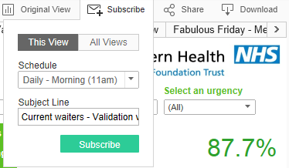

Step 4: Selecting your content
Do you wish to receive the single tab that you are currently viewing or all tabs within the report?
Many Tableau reports have multiple tabs across the top, each displaying a different view of the data. It is possible to receive only the tab you currently have selected by clicking “This View” or all tabs within the report by clicking “All Views”.

Click subscribe
Having selected your content please click the Subscribe button to complete your subscription.

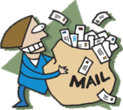
Junk email?

When first receiving your subscribed emails Outlook may wrongly identify them as ‘Junk email’ as the email is being sent from an automated account. You are able to resolve this by adding tableau.admin@shft.nhs.uk as a “Safe sender”. To do this go into Outlook, click on your Junk E-Mail folder and right click on the Tableau email that has been placed in your Junk E-Mail folder. Click “Junk” and then select “Junk E-Mail options”. If you get an Outlook warning pop up click OK, in the Junk E-Mail options menu click on the “Safe senders” tab, click “Add” and enter tableau.admin@shft.nhs.uk. Click OK and Apply and from now on your subscription emails will be delivered into your normal inbox.

