upgrade
What it means for you
10.5
Earlier this week we successfully upgrade our Tableau Server to version 10.5, enabling many new features and taking advantage of many Tableau improvements. If you have recently gone onto Tableau Server you may have noticed some differences; this guide shares the key changes and what the upgrade means for you.

Projects – The ‘no project’ blank screen  With 10.5, Tableau implemented a new piece of functionality, nested projects. This could be really useful to us as it will mean we can better structure our Tableau content and make it easier for you to find specific reports. For example within the Clinical data project we could created sub-projects for Mental Health, Adults Physical Health, Children’s and Trust Wide content.  Whilst we explore how we will potentially use nested projects you will see a ‘No Projects’ screen every time you access a project. This does not mean your reports have disappeared! To access the reports simply click on the Workbooks.  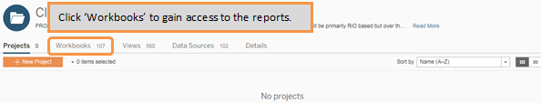 | Where have the Advanced Filters gone?  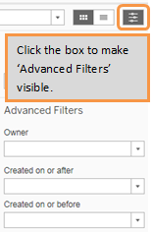  Many of you use the Advanced Filters to search for reports within Tableau. Prior to version 10.5 the Advanced Filters were permanently visible, when navigating content, on the left hand side of your screen.  The Advanced Filters are still available to you within Tableau however they are now hidden by default and are now located on the right hand side of your screen.  To view the Advanced Filters simply click on the little grey icon (highlighted right) and you will be able to use the search, tags and favourites options.

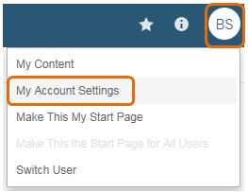
Uploading a profile picture
Should you wish to it is now possible to upload a picture to your Tableau Server Profile. Your uploaded picture will appear in the top right of the Tableau screen and will be visible to others should you complete actions such as entering comments against a report.
To upload an image click on your profile initials in the top right and then ‘My Account Settings’. Next click on the blue circle with your initials in it and upload an image from your computer. When finished click ‘Done’.

Downloading ‘Full data’ - An error when exporting to Excel

Unfortunately we have discovered a bug in version 10.5 of Tableau; the good news is this does not happen very often and Tableau have already confirmed they are working on an immediate fix!

The bug occurs when you attempt to download ‘Full data’ from a chart or table within a report; downloading only summary data is not impacted and this functionality still works correctly. The steps to download data are the same as they were in the previous version of Tableau; however this issue occurs when you open the exported data in Excel. Tableau is including a number of superfluous commas in the exported text data file and as such Excel is interpreting these additional commas as additional columns. This will cause your exported data to be misaligned with the column headers in Excel and for a number of blank columns to appear.

Whilst Tableau work to resolve the issue there is a local workaround that will allow you to open the exported ‘Full data’ text file and for it to appear correctly in Excel (i.e. with no blank or offset columns):

Step 1: When exporting the ‘Full data’ from Tableau choose to save the exported text file rather than opening it
Step 2: Import data into Excel using ‘From Text’ option  Step 3: Choose Delimited file type | Step 4: Select Comma delimiter and tick consecutive delimiters  Step 5: Click Finish  Your data will now be loaded correctly in Excel.

